**Lê Huỳnh Công Tiếp - 22692271**

**Link github**: https://github.com/Rai-LTKING/22692271_LeHuynhCongTiep_ShoppingSQLITE

1. Giao diện chính:

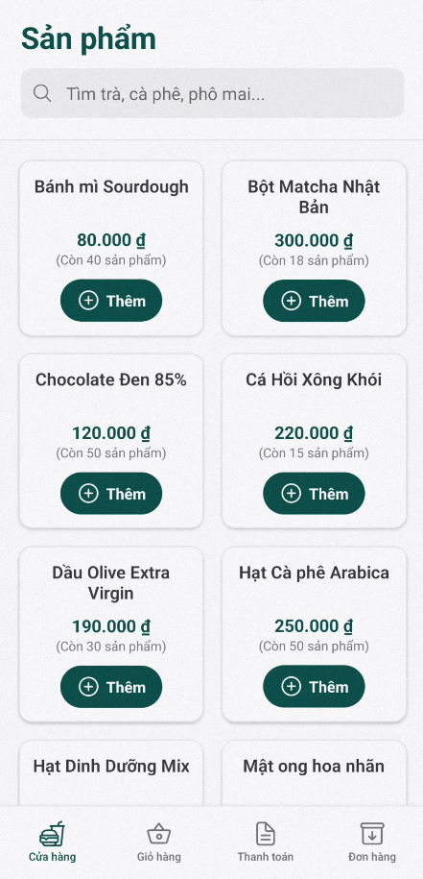

1. Tìm kiếm:

1. Thêm sản phẩm:

1. Giỏ hàng:

1. Trang thanh toán:

1. Xác nhận đặt hàng:

1. Trang đơn hàng:

1. Giỏ hàng trống:

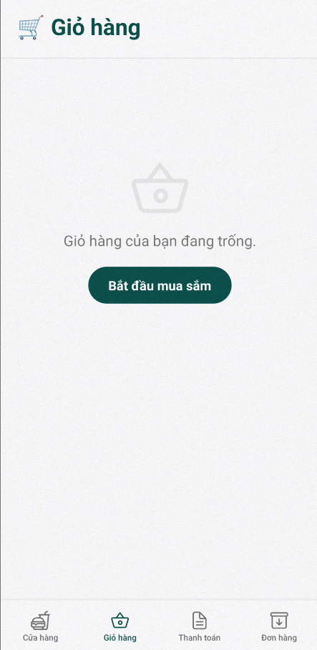

1. Thanh toán trống:

